**Implementation of Artificial Intelligence in Business Ecosystem**

**PHASE 2 – THE DESIGN PHASE**

**CONTENTS**

|  |  |  |
| --- | --- | --- |
| Serial Number | List of Contents | Page Number |
| 1.0 | **Architecture** |  |
| 2.0 | **Screen Layout** |  |
| 3.0 | **Database Design** |  |
| 3.1 | ER Diagram |  |
| 3.2 | Data Flow Diagram |  |
| 3.3 | Table Structure |  |
| 4.0 | **Use Case Diagram** |  |
| 5.0 | **Sequence Diagram** |  |
| 6.0 | **Test Plan** |  |
| 7.0 | **Limitations/Constraints/Drawbacks** |  |

1. **Architecture**

An Architecture Diagram is a graphical representation of a set of concepts, that are part of an architecture, including their principles, elements and components. It is a coherent set of concepts for a structure.

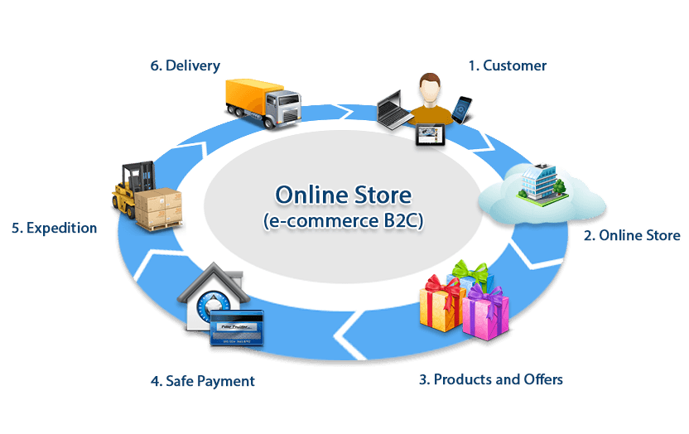

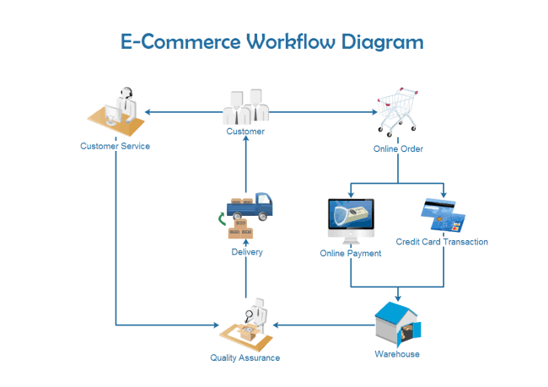

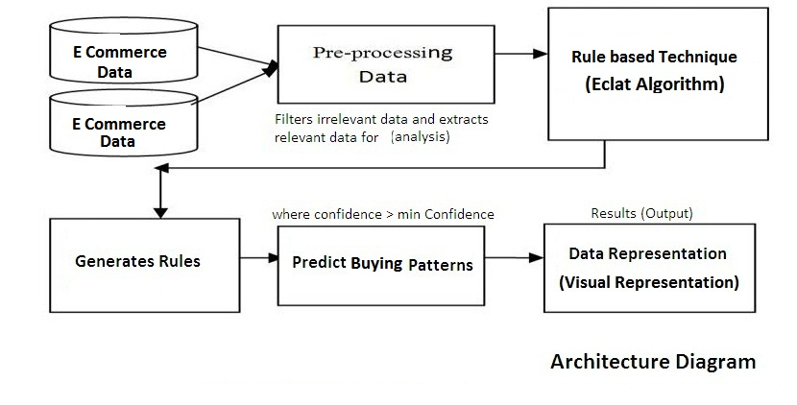

E-commerce is based on the client server Architecture. It is a Computing module in which the server hosts, delivers and manages most of the resources to be consumed by the client. In this proposed system architecture , ‘N’ numbers of clients are connected to a Central server.

From the above Architecture Block Diagram we Can conclude that:

E-Commerce Data is set of User profile data ,eco-products data..etc . Pre-processing Data filters irrelevant data from E-Commerce data and extracts only relevant data for analysis.

Rule Based Technique is a set of if-then Statements. Rule-based Technique provides automatic Problem solving tools for capturing human expertise and decision making.

In rule-Based technique, Inference engine takes input of facts from user interface and analyzes the rules and sends the queries or results back to the user interface.

The generated set of rules from rule based technique will be compared to a threshold value(80%). If the set of rules is greater or equal to the threshold value then buying pattern is predicted. Thus, predicted Buying pattern is Visually Represented as output for the User.

**2.0 Screen Layout**



X



X

X



X





X

**3.0 Database Design**

3.1 ER Diagram

An Entity-Relationship diagram (ERD) is a data modeling technique that graphically illustrates an information system’s entities and relationships between those entities. An ERD is a conceptual and representational model of data used to represent the entity framework infrastructure.

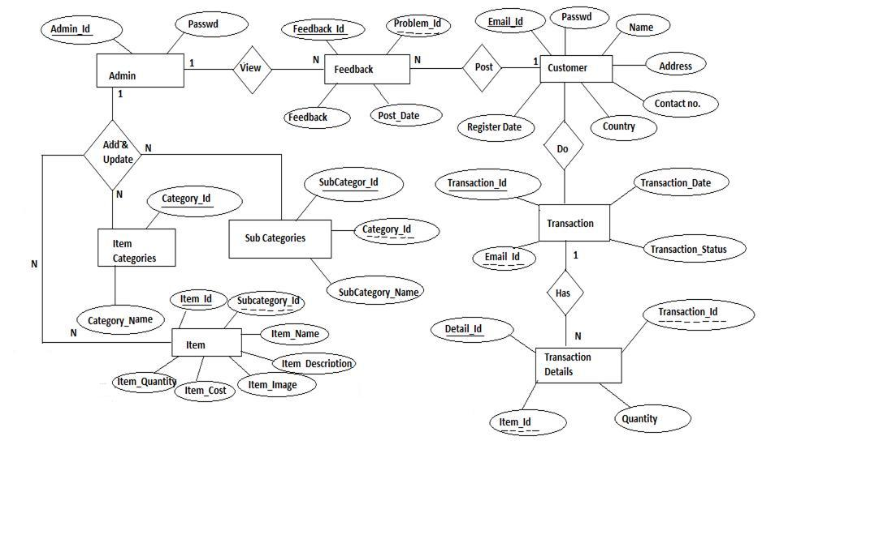

ER Diagrams are most often used to design or debug relational databases.

3.2 Data Flow Diagram

Data-flow diagram is a way of representing a flow of a data of a process or a system and information about the outputs and inputs of each entity and the process itself.

Business Entity/Admin :

Login

ADMIN

Change

View

Update/ Remove

Input

Eco product category

Eco product category

Eco product category

Password

Eco products sub-category

Eco products

Eco products

Eco products

Eco products order

Feedbacks

Visitor :

Input

Visitor

View

Home page

About us page

Search Eco product

Contact us page

Service page

AI Recommendation

shopping

Member :

Member

Login

Update/ Remove

Input

Orders placed

Eco product orders

Eco products

feedback

View

Home page

About us page

Eco products

Contact us page

Profile

AI Recommendation

shopping

**FLOW CHART**

Yes

No

Yes

No

No(Member)

Yes

Service page

Contact us page

About us page

Profile

Feedback

Order history

Place order

Review order

Password

Feedback

Orders

Eco products

Category

Is Entity

Login

Is visitor

Is valid

Start

Registration page

Ecoproducts

Search

Shopping

Logout

Stop

3.3 Table Structure

**ADMIN TABLE**

|  |  |  |  |  |
| --- | --- | --- | --- | --- |
| **No.** | **Attribute name** | **Data type** | **Constraints** | **Description** |
| 1 | Admin id | Varchar(10) | Primary key | Admin id |
| 2 | Password | Varchar(10) |  | Admin password |

**Table : Admin Details**

**ECO PRODUCT TABLE**

|  |  |  |  |  |
| --- | --- | --- | --- | --- |
| **No** | **Attribute name** | **Data type** | **Constraints** | **Description** |
| 1 | Eco product id | Int(10) | Primary key | Eco product id |
| 2 | Subcategory id | Int (10) | Foreign key | Eco product subcategory id |
| 3 | Eco product name | Char(10) |  | Eco product name |
| 4 | Eco product cost | Int(10) |  | Eco product cost |
| 5 | Eco product details | Char(10) |  | Eco product details |
| 6 | | Eco product image | Varchar(10) |  | Eco product images |
| 7 | | Quantity | Int(10) |  | Eco product Quantity |

**Table : Eco products details**

**ECO PRODUCT CATEGORY**

|  |  |  |  |  |
| --- | --- | --- | --- | --- |
| **No** | **Attribute name** | **Data type** | **Constraints** | **Description** |
| 1 | Category id | Int (10) | Primary key | Eco product category id |
| 2 | Category name | Char(10) |  | Eco product category name |

**Table : Eco Product Category**

**ECO PRODUCT SUBCATEGORY TABLE**

|  |  |  |  |  |
| --- | --- | --- | --- | --- |
| **No** | **Attribute name** | **Data type** | **Constraints** | **Description** |
| 1 | Subcategory id | Int (10) | Primary key | Eco product subcategory id |
| 2 | Category id | Int (10) | Foreign key | Eco product category id |
| 3 | Subcategory name | Char(10) |  | Eco product subcategory name |
| 4 | Description | Char(20) |  | Product description |

**Table : Eco product Subcategory**

**CUSTOMERTABLE**

|  |  |  |  |  |
| --- | --- | --- | --- | --- |
| **No.** | **Attribute Name** | **Data Type** | **Constraints** | **Description** |
| 1 | Email id | Varchar(10) |  | Customer Email id |
| 2 | Password | Varchar(10) |  | Password |
| 3 | Address | Char(10) |  | Customer address |
| 4  5  6  7 | Customer Name  Customer id  Country  Phone number | Char(10)  Int(10)  Char(10)  Int(10) | Primary key | Customer name  Customer id  Customer Country name  Customer phone number |

**Table: Customer Details**

**CUSTOMER TRANSACTION TABLE**

|  |  |  |  |  |
| --- | --- | --- | --- | --- |
| **No.** | **Attribute name** | **Data type** | **Constraints** | **Description** |
| 1 | Transaction date | Date |  | Customer order date |
| 2 | Transaction id | Int (10) | Primary key | Customer order id |
| 3 | Customer id | Int (10) | Foreign key | Customer id |
| 4 | Dispatched date | Date |  | Order delivery date |
| 5 | Status | Date |  | Order dispatch date |

**Table : Customer Transaction**

**FEED BACK TABLE**

|  |  |  |  |  |
| --- | --- | --- | --- | --- |
| **No.** | **Attribute name** | **Data type** | **Constraints** | **Description** |
| 1 | Feed Back id | Int (10) | Primary key | Feed Back id |
| 2 | Feed Back date | Date |  | Feed Back date |
| 3 | Customer id | Int (10) | Foreign key | Customer id |
| 4 | Feed Back | Char(20) |  | Feed Back about item |

**Table : Feed Back**

**CART DETAILS TABLE**

|  |  |  |  |  |
| --- | --- | --- | --- | --- |
| **No** | **Attribute name** | **Data type** | **Constraints** | **Description** |
| 1 | Cart id | Int (10) | primary key | Cart id |
| 2 | Customer id | Int (10) | Foreign key | Customer id |
| 3 | Eco product id | Int (10) | Foreign key | Eco product id |
| 4 | Quantity | Int (10) |  | Quantity |

**Table : Cart details**

**4.0** **Use Case Diagram**

A use case diagram at its simplest is a representation of a user’s interaction with the system that shows the relationship between the user and the different use cases in which the user is involved.

**Business Entity/Admin**

Change Password

Manage customer Feedback

Manage customer Eco Product order

Manage Eco Product

Manage Eco Product category

Login

**VISITOR**

Shopping

Search

Filter using Ai

View

Login

Registration

Services

Contact us

About us

Home

Home

About us

**Member**

Contact us

Login

Services

Place order

Review Order

Order history

View

Filter using Ai

Search

Shopping

Feedback

Profile update

**5.0 Sequence Diagram**

**Business Entity**

Logout

login

Un

sucessfl

Update

View

delete

View

View

Add &delete

Add & delete

View

Login

Successful

Password

Customer feedback

Customer orders

Eco product

Eco product category

Business entity

Login

**Visitor**

view

view

View

view

View

search

Contact us

About us

Eco Products

visitor

**Member**

Update

Add

View

Add

Delete

View

Login

Successfull

Profile

Feedback

Order history

Place order

Review order

Site member

Login

login

Unsuccessful

Logout

**6.0 Test Plan**

Testing is a process of executing a program to ensure that defined input will produce actual results that agree with required outputs

**Early Testing:** Conducting testing as soon as possible in development life cycle to find defects at early stages is called early testing. Early testing is helpful to reduce the cost of fixing defects.

* Why does software have defects?
* Incorrect requirements
* Wrong design
* Poor coding
* Complex business logic
* Complex technology
* Work pressure
* Frequently changing requirements.
* **Errors**: Any incorrect human action that produces a problem in the system is caller error.
* **Defect**: Deviation between expected behaviors to actual behavior of the system is called defect.
* **Failure**: The deviation identified by end-user while using a system is called a failure.

**WHITE BOX TESTING**

White Boxes focuses on the program control structure. Test cases are derived to ensure that all statements in the program have executed at level once during, testing and that all logical conditions implying that this test is typically applied to small program components. White Box testing methods were used to check whether the loop executed properly, different methods were applied at the boundaries and the execution was examined to be perfect..

**BLACK BOX TESTING**

Black Box Testing focuses on the functional requirements of the software; it enables to derive set of input conditions that fully exercise all functional requirements for a program. Black Box Testing tends to find out errors in data structure or external access, performance errors and initialization error.

**6.1 Purpose of Testing:**

Testing accomplishes a variety of things, but most importantly it measures the quality of the software we are developing. This view presupposes there are defects in the software waiting to be discovered and this view is rarely disproved or even disputed.

Several factors contribute to the importance of making testing a high priority of any software development effort. These include:

* Reducing the cost of developing the program.
* Ensuring that the application behaves exactly as we explain to the user for the vast majority of programs, unpredictability is the least desirable consequences of using an application.
* Reducing the total cost of ownership. By providing software that looks and behaves as shown in the documentation, the customers require fewer hours of training and less support from product experts.
* Developing customer loyalty and word-of-mouth market share.

**6.3 Test Cases:**

|  |  |  |  |  |
| --- | --- | --- | --- | --- |
| **TC#** | **Description** | **Expected Result** | **Actual Result** | **Status of Execution Pass/Fail** |
| TC01 | Execute/run the application | Application should run without any interrupts | ------ | ------ |
| TC02 | Verification of  Login Page | Enter User Name and Password. It should verify with database. | ------ | ------ |
| TC03 | Verification of Admin Page input User Name and password | If Admin Login Name & Password is valid then it should navigate to respective Admin home page. If invalid then show message that Input Username & Password is wrong. | ----- | ------- |
| TC04 | Verification of sensors | Sensors should be switched on to carry out information About any obstacle nearby so that user can be diverted. | ------- | ----- |
| TC05 | Verification of Audio button | The destination spoken by the blind is recorded through mobile and sent to the centralized server along with the source where the blind at present. | ------- | -------- |
| TC06 | Verification of view users button | The blind is completely tracked by the server and later their concerned people can see his tracks. | ------ | ------ |

### What is Ecommerce Testing?

eCommerce testing is defined as testing of an eCommerce (online shopping) application. It helps in the prevention of errors and adds value to the product by ensuring conformity to client requirements.

The objective of testing is to ensure

* Software reliability
* Software quality
* System Assurance
* Optimum performance and capacity utilization

Setting up an E-commerce system is a complex process and subject to many market-specific variables. To maintain the integrity of the E Commerce system, testing becomes compulsory

## Types of Testing for E-commerce System

A common type of testing included into e commerce system is

|  |  |  |
| --- | --- | --- |
| **Sr.#** | **Type of Testing** | **Testing Process** |
| 1 | Browser compatibility | * Lack of support for early browsers * Browser specific extensions * Browser testing should cover the main platforms (Linux, Windows, Mac etc.) |
| 2 | Page display | * Incorrect display of pages * Runtime error messages * Poor page download time * Dead hyperlink, plugin dependency, font sizing, etc. |
| 3 | Session Management | * Session Expiration * Session storage |
| 4 | Usability | * Non-intuitive design * Poor site navigation * Catalog navigation * Lack of help-support |
| 5 | Content Analysis | * Misleading, offensive and litigious content * Royalty free images and copyright infringement * Personalization functionality * Availability 24/7 |
| 6 | Availability | * Denial of service attacks * Unacceptable levels of unavailability |
| 7 | Back-up and Recovery | * Failure or fall over recovery * Backup failure * Fault tolerance |
| 8 | Transactions | * Transaction Integrity * Throughput * Auditing |
| 9 | Shopping order processing and purchasing | * Shopping cart functionality * Order processing * Payment processing * Order tracking |
| 10 | Internationalization | * Language support * Language display * Cultural sensitivity * Regional Accounting |
| 11 | Operational business procedures | * How well e-procedure copes * Observe for bottlenecks |
| 12 | System Integration | * Data Interface format * Interface frequency and activation * Updates * Interface volume capacity * Integrated performance |
| 13 | Performance | * Performance bottlenecks * Load handling * Scalability analysis |
| 14 | Login and Security | * Login capability * Penetration and access control * Insecure information transmission * Web attacks * Computer viruses * Digital signatures |

## **Challenges of E-commerce Testing**

* Compliance with security guidelines to safeguard customer data and identity
* Compliance with accessibility standards to support multi-lingual markets and business regions
* End to end testing and test management for large e-commerce transformation programs
* Scalability and reliability of applications
* If a user is signed in for a long time, ensure there is a session timeout. All websites have different thresholds.
* Message/email confirmation with the order number that is generated after the purchase is made.

**7.0 Limitations/Constraints/Drawbacks**

**1) Security**

Online portals have been in the news a lot because of hacks by cybercriminals and hackers. It is a very serious issue as your account might be hacked because of negligence and wiped out clean of the existing cash. This is a harsh reality of e-commerce sites and a website cannot give this assurance that the financial information cannot be compromised on its portal. The website owner needs to take important steps to change its password so as to stop any data breaches. It is important to remain vigilant and proactive to protect the website and ultimately the customer related information. Security has been a concern since its inception and is considered a major disadvantage of e-commerce.

**2) Site crash**



E-commerce is fully dependent on internet connection. A major disadvantage of e-commerce is putting a stop to buying capabilities because of a site crash. Such a small word site crash but has the ability to put a whole business down within a few seconds. This can happen if you do not have a good bandwidth connection as you will face serious issues while loading pages and placing orders. It is impossible to make a purchase if the site you are looking at crashes down. Ensure that your website is on the right platform where there are already precautions in place for this eventuality.

**3) Late delivery**

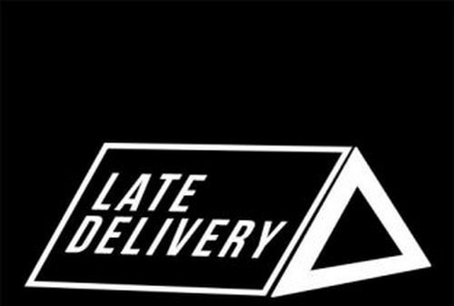

Late delivery is one of the common disadvantages of e-commerce platforms. While ordering a product the customer is assured that it will reach him in maximum seven days or a particular time period. In most cases that does not happen and you are kept waiting for it. Ultimately when the information reaches you that the product will be delivered on this day the portal is not specific about the timings. There are several instances when a person who is going to collect the parcel had to wait for hours for the delivery. His whole day is wasted and he could not go outside as per his original schedule. Such a situation makes the customer angry as he feels unnecessarily harassed.

**4) Huge technological cost**



E-commerce requires advanced platforms to better their performance. If it faces disturbances in the form of software, network or domain issue it will not be able to offer seamless transactions. The apt technical infrastructure is costly and needs huge investment. It also needs to be upgraded periodically to stay with changing times. Huge technological cost for a successful venture is a disadvantage of the e-commerce portal.

**5) Shipping problems**

E-commerce stores run successfully because it can ship its products from anywhere to everywhere with ease. It has a strong network that helps it in its endeavor. In a physical store, a buyer chooses a product, purchases it and leaves the store with the item. This is not so on an online store where the customer has to choose and buy and then wait for the product to arrive at his doorstep within the stipulated time frame. Shipping is an integral part of commerce and if you do not have appropriate infrastructure then it can cause serious issues and become a disadvantage of e-commerce.

**6) Fear**



People fear the unknown. E-commerce transactions are mostly faceless and paperless without any due proof. Most of the organizations do not have a physical existence and customers are hesitant to make card payments beforehand. They fear that if the desired product does not arrive then they will lose their money. One of the disadvantages of e-commerce is the absence of the physical existence of the store.

**7) High labour cost**

 High labour cost is a serious disadvantage of the e-commerce platform. You need to hire technically sound, trained and qualified workforce for your website who are talented and capable of handling them in an efficient manner. You need to shed a large chunk of money to hire and retain a talented pool of workers that will prove an immense help in handling all transactions.

**8) Lack of personal touch**

When you enter a retail outlet you are welcomed at the gate and as you enter inside there are several employees to help you in case of any difficulties. When you are online and making a choice there is no one to help you during your visit. The personal touch at the physical store serves as an encouragement and feels good. The interaction with sales associates helps us in making choices. This is why soft personal touches are encouraged in physical outlets. This experience is valuable but is not available at online outlets and seems like a disadvantage of e-commerce.

**9) Credit card fraud**

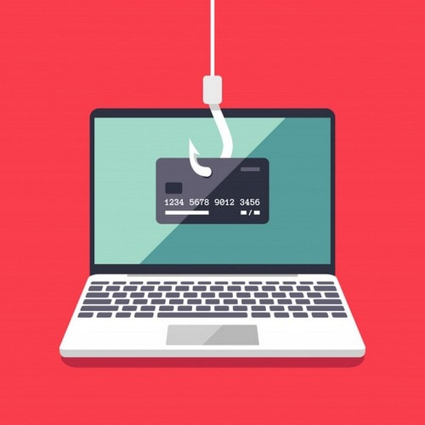

Online transactions are mostly made by debit card, credit card, and internet banking and in very few cases with cash on delivery option. Yes, the website owners try to take every available precaution to protect the card details but what if the site is hacked by cybercriminals. It is a growing concern as we hear news of data hacks regularly. The websites need to place proper blockers in place because the customers will lose faith and will stop making online payments. Stop it before it starts proving a serious disadvantage for e-commerce sites.

**10) Dependency on the website**

An e-commerce site is heavily dependent on its website. If it is not properly projected or the software is not implemented the site can face technology hiccups. It then comes under the serious radar. Customers tend to lose faith very easily and shift their loyalties to other portals that they find convenient. The portal will suffer substantial loss because of this action. Do not keep all the eggs in one basket as the dependency on the website can prove a disadvantage of e-commerce in times of crises.

**11) Severe competition**

Healthy competition is considered a plus in the business sector but what happens when there are unimaginable portals for a single product. It is surely a disadvantage of e-commerce when that happens because the competition turns inwards and the companies try harder to attract a large chunk of the consumer base. This forces them to drop their prices by allowing discounts, incentives and other allowances on their products. Obviously, the quality of the products suffers and at the end of the day, it is the customers who are made a fool of. Although the popularity has forced several business houses to shift base on online medium but running an e-commerce operation is not a bed of roses as it also includes several challenges and disadvantages like a rose with thorns.

Software or web servers are necessary along with network bandwidth for a successful e-commerce transaction. Sometimes a site crashes down and you are in serious need of a product. Security has become a serious issue as hackers are on the look-out for any loopholes to make mischief. Although purchasing products is easy but how can you check the quality of the product and what about its availability.

It takes a few days for the product to arrive and what will happen when you need to use the item as soon as possible. Navigating the choppy waters is not an easy feat as individuals have to face several challenges.

--------------